Индивидуальное задание:

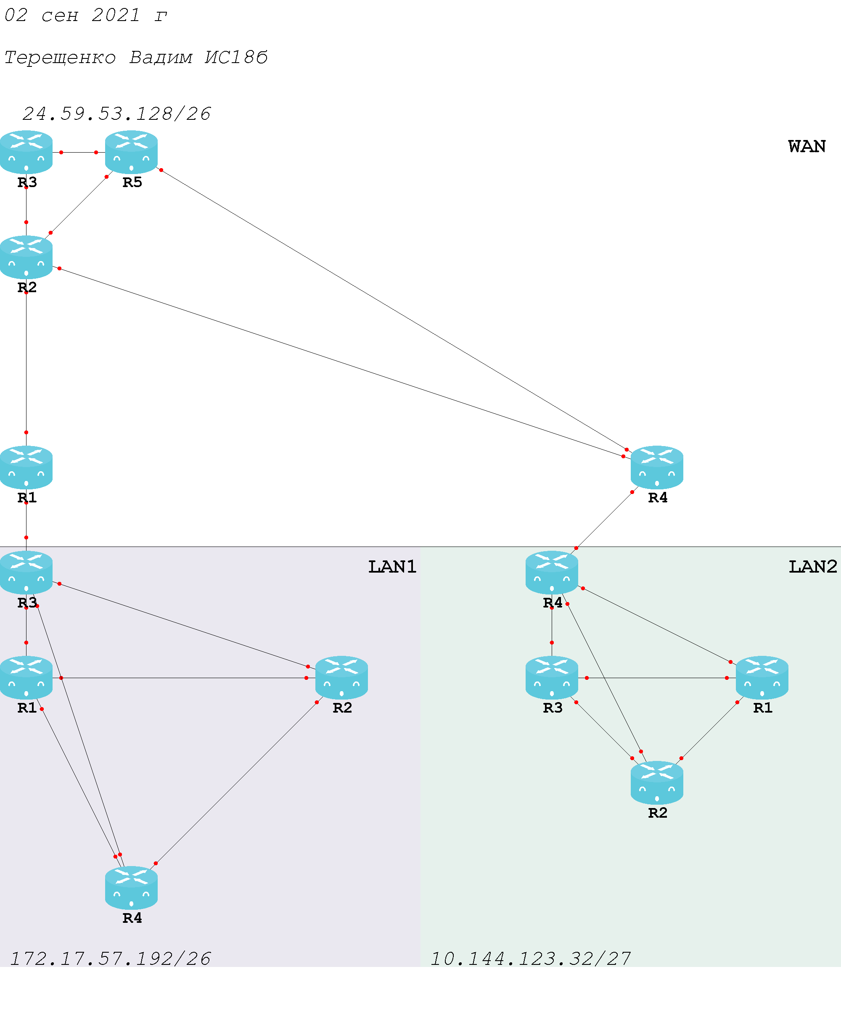

|  |  |  |  |  |
| --- | --- | --- | --- | --- |
| Пулл | Выделено адресов | IP адрес подсети | Диапазон адресов | Широковещание |
| LAN1  172.17.57.192/26 | 32 | 172.17.57.192/27 | 172.17.57.193 - 172.17.57.222 | 172.17.57.223 |
| 8 | 172.17.57.224/29 | 172.17.57.225 - 172.17.57.230 | 172.17.57.231 |
| 8 | 172.17.57.232/29 | 172.17.57.233 - 172.17.57.238 | 172.17.57.239 |
| 8 | 172.17.57.240/29 | 172.17.57.241 - 172.17.57.246 | 172.17.57.247 |
| 4 | 172.17.57.248/30 | 172.17.57.249 - 172.17.57.250 | 172.17.57.251 |
| 4 | 172.17.57.252/30 | 172.17.57.253 - 172.17.57.254 | 172.17.57.255 |
| LAN2  10.144.123.32/27 | 8 | 10.144.123.32/29 | 10.144.123.33 - 10.144.123.38 | 10.144.123.39 |
| 8 | 10.144.123.40/29 | 10.144.123.41 - 10.144.123.46 | 10.144.123.47 |
| 4 | 10.144.123.48/30 | 10.144.123.49 - 10.144.123.50 | 10.144.123.51 |
| 4 | 10.144.123.52/30 | 10.144.123.53 - 10.144.123.54 | 10.144.123.55 |
| 4 | 10.144.123.56/30 | 10.144.123.57 - 10.144.123.58 | 10.144.123.59 |
| 4 | 10.144.123.60/30 | 10.144.123.61 - 10.144.123.62 | 10.144.123.63 |

Таблица 1.1. Распределение адресного пространства

|  |  |  |  |  |
| --- | --- | --- | --- | --- |
| Пулл | Выделено адресов | IP адрес подсети | Диапазон адресов | Широковещание |
| WAN  24.59.53.128/26 | 8 | 24.59.53.128/29 | 24.59.53.129 - 24.59.53.134 | 24.59.53.135 |
| 8 | 24.59.53.136/29 | 24.59.53.137 - 24.59.53.142 | 24.59.53.143 |
| 8 | 24.59.53.144/29 | 24.59.53.145 - 24.59.53.150 | 24.59.53.151 |
| 8 | 24.59.53.152/29 | 24.59.53.153 - 24.59.53.158 | 24.59.53.159 |
| 8 | 24.59.53.160/29 | 24.59.53.161 - 24.59.53.166 | 24.59.53.167 |
| 8 | 24.59.53.168/29 | 24.59.53.169 - 24.59.53.174 | 24.59.53.175 |
| 8 | 24.59.53.176/29 | 24.59.53.177 - 24.59.53.182 | 24.59.53.183 |
| 8 | 24.59.53.184/29 | 24.59.53.185 - 24.59.53.190 | 24.59.53.191 |

Таблица 1.1. Распределение адресного пространства

